**Unit-3**

**Neural Network:**

Neural networks are at the core of modern machine learning and artificial intelligence. Among the many types, multilayer perceptrons (MLPs) serve as a foundational building block for deep learning systems. This tutorial introduces the concept of artificial neural networks, explores how MLPs work, and walks through key components like backpropagation and stochastic gradient descent.

An [**artificial neural network**](https://www.datacamp.com/tutorial/introduction-to-deep-neural-networks) (ANN) is a machine learning model inspired by the structure and function of the human brain's interconnected network of neurons. It consists of interconnected nodes called artificial neurons, organized into layers. Information flows through the network, with each neuron processing input signals and producing an output signal that influences other neurons in the network.

### Key Components of a Neural Network

1. **Neurons (Nodes)**:

Each node, or "neuron," represents a unit of computation. It receives one or more inputs, processes them, and produces an output.Each input to a neuron is typically associated with a weight, which determines the importance of the input in the computation.

1. **Layers**:

**Input Layer**: The first layer of the network, which takes in the raw input data.

**Hidden Layers**: Layers between the input and output layers. These layers enable the network to learn complex representations and features. The number of hidden layers and the number of neurons in each layer form the network’s architecture.

**Output Layer**: The last layer that produces the final output, which could be a prediction (e.g., a class label in classification tasks or a numeric value in regression tasks).

1. **Weights**:

Each connection between neurons has a weight associated with it. During training, these weights are adjusted to minimize the difference between the predicted and actual outputs.

1. **Activation Functions**:

Activation functions determine the output of a neuron based on the weighted sum of its inputs. Common activation functions include:

* + - **Sigmoid**: Maps the input to a range between 0 and 1.
    - **ReLU (Rectified Linear Unit)**: Outputs the input directly if it is positive; otherwise, it outputs zero.
    - **Tanh**: Maps the input to a range between -1 and 1, making it useful in some cases for reducing gradients.

1. **Bias**:

Each neuron often has an additional parameter called the bias, which shifts the activation function, allowing the network to fit the data better.

### How a Neural Network Works

1. **Forward Propagation**:

In forward propagation, the input data is passed through the network, layer by layer, from the input layer to the output layer.

Each neuron computes a weighted sum of its inputs, applies an activation function to produce an output, and passes this output to the next layer.

This process continues until the output layer produces the final result.

1. **Loss Function**:

After the network produces an output, it is compared with the actual target (label) using a loss function (also known as a cost or error function).

The loss function calculates the difference between the predicted output and the actual output. Common loss functions include:

* + - **Mean Squared Error (MSE)** for regression problems.
    - **Cross-Entropy Loss** for classification problems.

1. **Backpropagation**:

Backpropagation is a method for calculating the gradient of the loss function with respect to each weight in the network.The network adjusts each weight by moving in the direction that reduces the error. This is typically done using an optimization algorithm like stochastic gradient descent (SGD) or one of its variants (e.g., Adam, RMSprop).This iterative process continues until the loss is minimized or reaches a satisfactory level.

1. **Training the Network**:

During training, the network learns the optimal weights that minimize the error on the training data.Training usually involves multiple passes over the data (epochs) until the network achieves a satisfactory performance level.

### Types of Neural Networks

There are many different types of neural networks, each designed for specific tasks:

## 1. Feedforward Neural Networks

[Feedforward neural networks](https://www.geeksforgeeks.org/multilayer-feed-forward-neural-network-in-data-mining/) are a form of artificial neural network where without forming any cycles between layers or nodes means inputs can pass data through those nodes within the hidden level to the output nodes.

* **Architecture:** Made up of layerswith unidirectional flow of data (from input through hidden and the output layer).
* **Training:**Backpropagation is often used during training for the main aim of reducing the prediction errors.
* **Applications:**In visual and voice recognition, NLP, financial forecasting, and recommending system

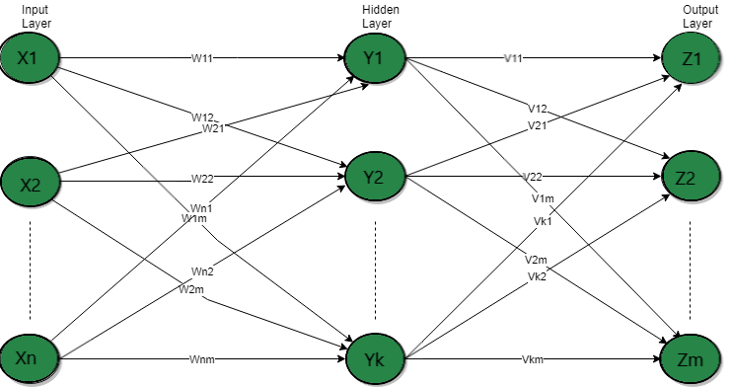

## 2. Convolutional Neural Networks (CNNs)

[Convolutional neural networks](https://www.geeksforgeeks.org/introduction-convolution-neural-network/)structure is focused on processing the grid type data like images and videos by using convolutional layers filtering driving the patterns and spatial hierarchies.

* **Key Components:**Utilizing convolutional layers, pooling layers and fully connected layers.
* **Applications:** Used for classification of images, object detection, medical imaging analyzes, autonomous driving and visualization in augmented reality.

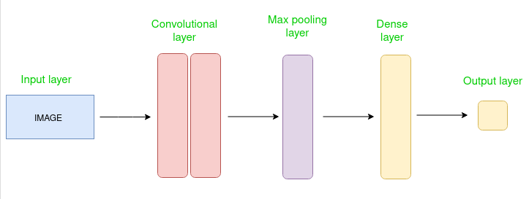

## 3. Recurrent Neural Networks (RNNs)

[Recurrent neural network](https://www.geeksforgeeks.org/introduction-to-recurrent-neural-network/) handles sequential data in which the current output is a result of previous inputs by looping over themselves to hold internal state (memory).

* **Architecture:** Contains recurrent connections that enable feedback loops for processing sequences.
* **Challenges:** Problems such as vanishing gradients become apparent since they limit the mode detectors’ ability to comprehensively capture interdependence on a long scale.
* **Applications:** Language translation, open-ended text classification, ones to ones interaction, and time series prediction are its applications.

## 4. Long Short-Term Memory Networks (LSTMs)

[Long Short-Term Memory Networks (LSTMs)](https://www.geeksforgeeks.org/deep-learning-introduction-to-long-short-term-memory/) are a variant of RNNs. They exhibit memory cells to solve the disappearing gradient issue and keep large ranges of information in their memory.

* **Key Features:**Capture memory cells in pass information flowing and graduate greediness issue.
* **Applications**: Value of RNNs is in terms of importing long-term memory into the model e.g., language translation, and time-series forecasting.

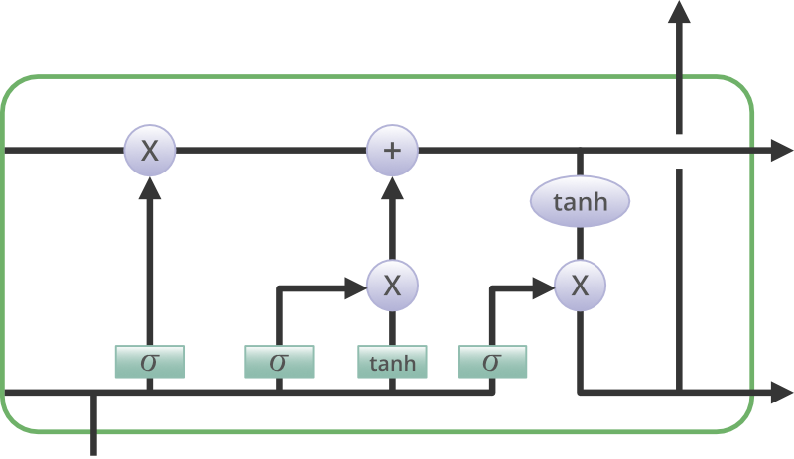

## 5. Gated Recurrent Units (GRUs)

[Gated Recurrent Units (GRUs)](https://www.geeksforgeeks.org/gated-recurrent-unit-networks/) is the second usual variant of RNNs which is working on gating mechanism just like LSTM but with little parameter.

* **Advantages:** Vanishing gradient issue is addressed and it is compute-efficient than LSTM.
* **Applications:** LSTM is also involved in tasks that can be categorized as similar to speech recognition and text monitoring.

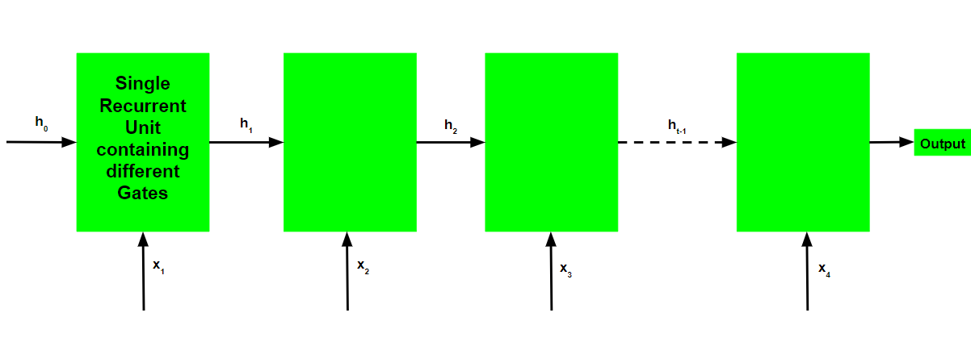

## 6. Radial Basis Function Networks (RBFNs)

[Radial basis function (RBF)](https://www.geeksforgeeks.org/radial-basis-function-kernel-machine-learning/)networks can be regarded as models which define radial basis functions that are very useful in the function approximation and classification approaches, being useful in complex input-output data modelling.

* **Applications:** It includes regression, pattern recognition, and system control methods for fast-tracking.

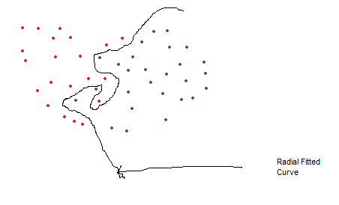

## 7. Self-Organizing Maps (SOMs)

[Self-Organizing Maps](https://www.geeksforgeeks.org/self-organising-maps-kohonen-maps/)are unsupervised neural networks; these networks are used for unsupervised cluster generation based on the retaining of topological features of the high dimensional data from an upper dimensional source, transformed into low dimensional form of output data.

* **Features:** Design methods that reduces the dimension of data from the high dimension into a low dimension without loss of the underlying geometry of the data.
* **Applications:** Visualizing data, discovering customers segments, locating anomalies; and selecting needed features.

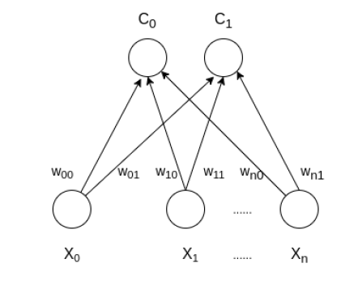

## 8. Deep Belief Networks (DBNs)

The architecture of the[Deep Belief Networks](https://www.geeksforgeeks.org/deep-belief-network-dbn-in-deep-learning/) is built on many stochastic, latent variables that are used for both deep supervised and unsupervised tasks such as nonlinear feature learning and mid dimensional representation.

* **Function:**If you are looking for the most effective architecture of data that can be learned via classification, this algorithm clearly emerges as the winner.
* **Applications:**Image and voice recognition, natural language understanding, and smart devices as recommendations systems.

## 9. Generative Adversarial Networks (GANs)

[Generative Adversarial Networks](https://www.geeksforgeeks.org/generative-adversarial-network-gan/)has made up of of two neural networks, the generator and discriminator, which compete against each other. The generator creates a fake generated data, and the discriminator learns to differentiate the real from and fake data.

* **Working Principle:**Generator evolves after each iteration while the fake data being generated. This simultaneously makes the discriminator more discriminating as it determines whether the components are real or generated.
* **Applications:** They have proved useful not only for pattern generation but also data augmentation, style transfer, and learning without any supervision.

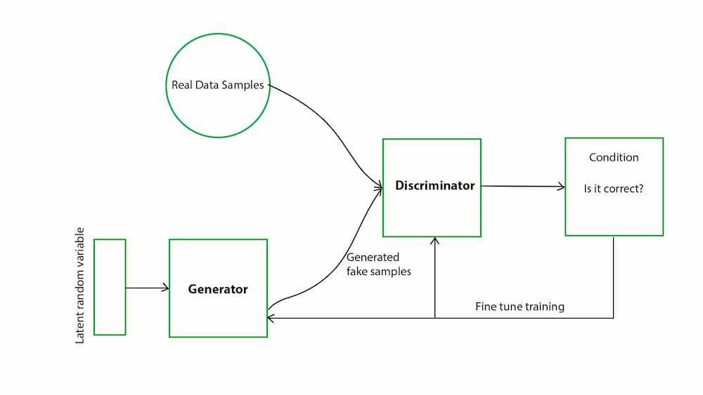

## 10. Autoencoders (AE)

[Autoencoders](https://www.geeksforgeeks.org/auto-encoders/) are feedforward networks (ANNs) that are trained to acquire the most helpful presentations of the information through the process of re-coding the input data. The encoder is pinpointed to precisely map the input into the legal latent space representation, while the decoder does the opposite, decoding the space from this representation.

* **Functionality:** Help in techniques like dimensionality reduction, information extraction, noise removal, and generative modelling the images become comprehensible.
* **Types:** Variants include undercomplete, overcomplete, and variational autoencoders.

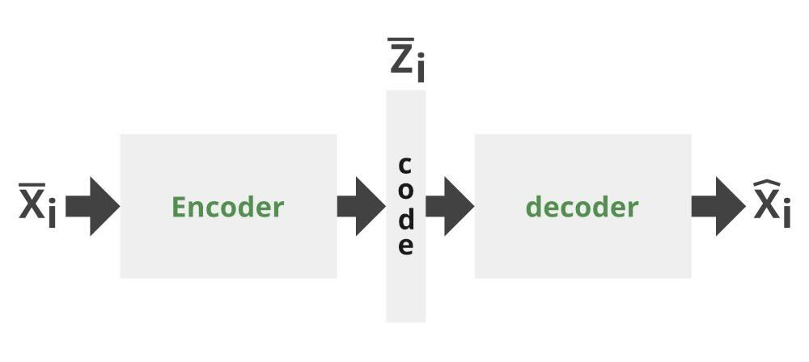

### Applications of Neural Networks

Neural networks are versatile and widely used across numerous domains:

1. **Image Recognition and Computer Vision**:

CNNs are used extensively for image classification, object detection, facial recognition, and medical image analysis.

1. **Natural Language Processing (NLP)**:

RNNs, transformers, and other neural network architectures are used for language translation, sentiment analysis, chatbots, and more.

1. **Speech Recognition**:

Neural networks power many of the latest speech recognition systems in virtual assistants, transcription, and language learning applications.

1. **Time-Series Forecasting**:

RNNs are used in finance, economics, and meteorology for predicting future data points based on historical trends.

1. **Recommendation Systems**:

Many e-commerce and streaming platforms use neural networks to personalize recommendations based on user preferences and interactions.

1. **Game Playing and Autonomous Systems**:

Deep reinforcement learning, a combination of neural networks and reinforcement learning, has been used in creating AI systems that can play games, control robots, and drive cars.

### Advantages and Challenges of Neural Networks

#### Advantages:

* **Ability to Model Complex Relationships**: Neural networks can approximate complex, non-linear relationships in data.
* **Feature Learning**: They automatically learn features from raw data, which reduces the need for manual feature engineering.
* **Scalability**: Neural networks can handle large datasets and high-dimensional data, making them suitable for "big data" applications.

#### Challenges:

* **Data Requirements**: Neural networks typically require large amounts of labeled data for effective training, which can be resource-intensive.
* **Computationally Expensive**: Training deep neural networks requires significant computational power, often involving GPUs or TPUs.
* **Interpretability**: Neural networks are often considered "black boxes," making it difficult to interpret how they arrive at their predictions.
* **Risk of Overfitting**: Without careful tuning, neural networks can overfit the training data, especially with limited data or very deep architectures.

### Summary

Neural networks are a powerful tool in machine learning, inspired by the human brain, and have proven incredibly effective at modeling complex patterns in data. They consist of multiple layers and neurons, use activation functions, and rely on backpropagation and optimization techniques to learn from data. With applications spanning from image recognition to NLP, neural networks have become central to modern artificial intelligence, although they require large datasets and computational resources to train effectively.

# 1. Perceptron: The Simplest Neural Unit

A **perceptron** is the earliest form of a neural network unit, introduced by **Frank Rosenblatt** in 1958. It is a **binary classifier** that makes predictions based on a linear combination of input features. The perceptron algorithm was one of the first algorithms used to implement a simple neural network.

**Perceptrons are supervised learning algorithms and is a type of an ANN**

## Components of a Perceptron:

* **Inputs**: The perceptron takes several inputs (x1,x2,…,xn)
* **Weights**: Each input is associated with a weight (w1,w2,…,wn).
* **Bias**: A bias term (b) is added to shift the decision boundary.
* **Activation Function**: The perceptron uses a **step function** (a simple thresholding function) to determine whether the weighted sum of inputs plus the bias is above or below a certain threshold.
* The mathematical representation is:

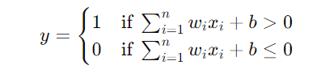

* **Binary Output**: The output of a perceptron is binary (1 or 0), making it suitable for linearly separable classification problems.

## Limitations of Perceptron:

* **Linear separability**: The perceptron can only solve problems that are linearly separable (i.e., it can only classify data that can be separated by a straight line or hyperplane). It cannot solve more complex problems like XOR.
* **Single-layer model**: The original perceptron is a single-layer model and does not have hidden layers, limiting its expressiveness.

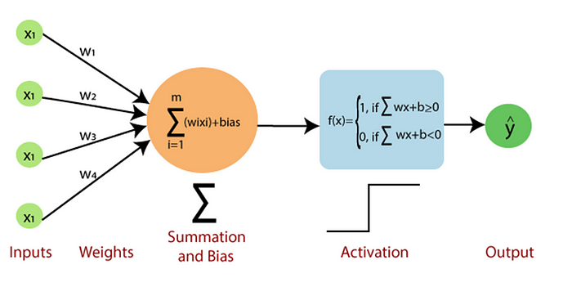

# 2. Neuron: A Generalized Unit in Neural Networks

A **neuron**, or artificial neuron, is a more generalized version of the perceptron and is the building block of modern deep learning architectures. Neurons in deep learning are part of **multi-layer neural networks**, which can have multiple hidden layers.

## Key Differences and Features of a Neuron:

* **Activation Function**: Unlike the perceptron, which uses a simple step function for activation, neurons in modern neural networks can use a variety of activation functions, such as:

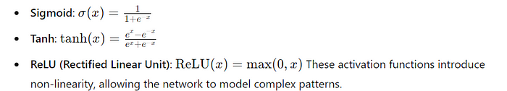

* **Multi-layer Networks**: Neurons are part of more sophisticated architectures called **multi-layer perceptrons (MLPs)** or deep neural networks, where neurons are organized into layers (input layer, hidden layers, and output layer). Each layer performs computations, and the output of one layer is fed as input to the next.
* **Continuous Output**: Neurons can output continuous values, unlike the binary output of a perceptron. This makes them more versatile for tasks like regression, multi-class classification, and complex feature extraction.
* **Learning through Backpropagation**: Neurons in deep learning models are trained using **backpropagation** and gradient descent, which adjusts the weights based on the error between the predicted and actual outputs. The perceptron uses a simpler update rule that works only for linearly separable problems.

## Modern Neural Networks:

* **Deep Learning Neurons**: In modern deep learning, neurons are the generalized units that can handle non-linear patterns and are stacked in multiple layers, giving rise to **deep neural networks (DNNs)**.
* **Non-linearity**: The introduction of non-linear activation functions allows neurons to model more complex, non-linearly separable data, overcoming the limitations of the simple perceptron

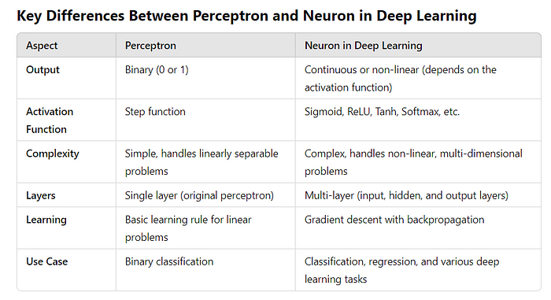

# ****Difference between SLP and MLP****

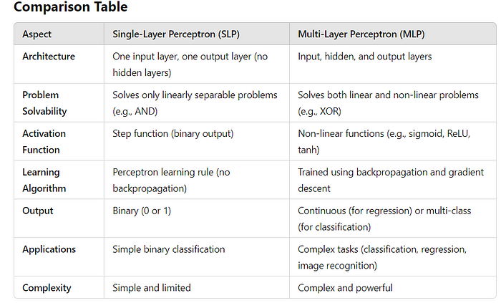

**Deep Learning:**

Deep learning is a specialized subset of machine learning that utilizes artificial neural networks with multiple layers (deep neural networks) to analyze and learn from large datasets. It's like giving a computer the ability to learn and recognize complex patterns, just like a human brain.

Here's a more detailed explanation:

* **Machine Learning:**

Machine learning (ML) is a field of artificial intelligence (AI) that allows computers to learn from data without being explicitly programmed. It involves algorithms that can improve their performance over time as they are exposed to more data.

* **Deep Learning:**

Deep learning (DL) is a specific type of ML that uses artificial neural networks with multiple layers (deep neural networks) to analyze and learn from data. These networks are inspired by the structure and function of the human brain, allowing computers to learn and make predictions on complex patterns.

* **Deep Neural Networks:**

These networks consist of multiple layers of interconnected nodes (neurons) that process information in a hierarchical manner. Each layer learns increasingly complex features from the data, enabling the network to make more sophisticated predictions.

## ****How Deep Learning Works****?

[**Neural network**](https://www.geeksforgeeks.org/neural-networks-a-beginners-guide/)consists of layers of interconnected nodes, or neurons, that collaborate to process input data. In a **fully connected deep neural network**, data flows through multiple layers, where each neuron performs nonlinear transformations, allowing the model to learn intricate representations of the data.

In a deep neural network, the **input layer** receives data, which passes through **hidden layers** that transform the data using nonlinear functions. The final **output layer** generates the model’s prediction.

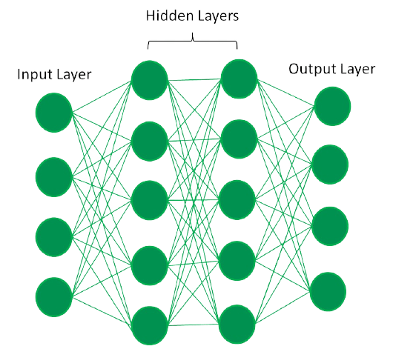

## Deep Learning in Machine Learning Paradigms

* [**Supervised Learning**](https://www.geeksforgeeks.org/supervised-machine-learning/): Neural networks learn from labeled data to predict or classify, using algorithms like CNNs and RNNs for tasks such as image recognition and language translation.
* [**Unsupervised Learning**](https://www.geeksforgeeks.org/unsupervised-learning/): Neural networks identify patterns in unlabeled data, using techniques like Autoencoders and Generative Models for tasks like clustering and anomaly detection.
* [**Reinforcement Learning**](https://www.geeksforgeeks.org/what-is-reinforcement-learning/): An agent learns to make decisions by maximizing rewards, with algorithms like DQN and DDPG applied in areas like robotics and game playing.

## ****Difference between Machine Learning and Deep Learning****

Machine learning and Deep Learning both are subsets of artificial intelligence but there are many similarities and differences between them.

| **Machine Learning** | **Deep Learning** |
| --- | --- |
| Apply statistical algorithms to learn the hidden patterns and relationships in the dataset. | Uses artificial neural network architecture to learn the hidden patterns and relationships in the dataset. |
| Can work on the smaller amount of dataset | Requires the larger volume of dataset compared to machine learning |
| Better for the low-label task. | Better for complex task like image processing, natural language processing, etc. |
| Takes less time to train the model. | Takes more time to train the model. |
| A model is created by relevant features which are manually extracted from images to detect an object in the image. | Relevant features are automatically extracted from images. It is an end-to-end learning process. |
| Less complex and easy to interpret the result. | More complex, it works like the black box interpretations of the result are not easy. |
| It can work on the CPU or requires less computing power as compared to deep learning. | It requires a high-performance computer with GPU. |

## ****Evolution of Neural Architectures****

The journey of deep learning began with the [**perceptron**](https://www.geeksforgeeks.org/what-is-perceptron-the-simplest-artificial-neural-network/), a single-layer neural network introduced in the 1950s. While innovative, perceptrons could only solve linearly separable problems, failing at more complex tasks like the XOR problem.

This limitation led to the development of [**Multi-Layer Perceptrons (MLPs)**](https://www.geeksforgeeks.org/multi-layer-perceptron-learning-in-tensorflow/). It introduced hidden layers and non-linear activation functions. MLPs, trained using **[backpropagation](https://www.geeksforgeeks.org/backpropagation-in-neural-network/" \t "_blank)**, could model complex, non-linear relationships, marking a significant leap in neural network capabilities.

This evolution from perceptrons to MLPs laid the groundwork for advanced architectures like CNNs and RNNs, showcasing the power of layered structures in solving real-world problems.

## Types of neural networks

**1. [Feedforward neural networks (FNNs)](https://www.geeksforgeeks.org/understanding-multi-layer-feed-forward-networks/)** are the simplest type of ANN, where data flows in one direction from input to output. It is used for basic tasks like classification.

**2.**[**Convolutional Neural Networks (CNNs)**](https://www.geeksforgeeks.org/introduction-convolution-neural-network/) are specialized for processing grid-like data, such as images. CNNs use convolutional layers to detect spatial hierarchies, making them ideal for computer vision tasks.

**3.**[**Recurrent Neural Networks (RNNs)**](https://www.geeksforgeeks.org/recurrent-neural-networks-explanation/)are able to process sequential data, such as time series and natural language. RNNs have loops to retain information over time, enabling applications like language modeling and speech recognition. Variants like LSTMs and GRUs address vanishing gradient issues.

**4.**[**Generative Adversarial Networks (GANs)**](https://www.geeksforgeeks.org/generative-adversarial-network-gan/) consist of two networks—a generator and a discriminator—that compete to create realistic data. GANs are widely used for image generation, style transfer, and data augmentation.

**5. [Autoencoders](https://www.geeksforgeeks.org/auto-encoders/" \t "_blank)** are unsupervised networks that learn efficient data encodings. They compress input data into a latent representation and reconstruct it, useful for dimensionality reduction and anomaly detection.

**6.**[**Transformer Networks**](https://www.geeksforgeeks.org/getting-started-with-transformers/) has revolutionized NLP with self-attention mechanisms. Transformers excel at tasks like translation, text generation, and sentiment analysis, powering models like GPT and BERT.

## ****Deep Learning Applications****

### 1. Computer vision

In computer vision, deep learning models enable machines to identify and understand visual data. Some of the main applications of deep learning in computer vision include:

* [**Object detection and recognition**](https://www.geeksforgeeks.org/what-is-object-detection-in-computer-vision/)**:**Deep learning models are used to identify and locate objects within images and videos, making it possible for machines to perform tasks such as self-driving cars, surveillance, and robotics.
* [**Image classification**](https://www.geeksforgeeks.org/what-is-image-classification/)**:**Deep learning models can be used to classify images into categories such as animals, plants, and buildings. This is used in applications such as medical imaging, quality control, and image retrieval.
* [**Image segmentation**](https://www.geeksforgeeks.org/explain-image-segmentation-techniques-and-applications/)**:**Deep learning models can be used for image segmentation into different regions, making it possible to identify specific features within images.

### 2. Natural language processing (NLP)

In NLP, deep learning model enable machines to understand and generate human language. Some of the main applications of deep learning in NLP include:

* **Automatic Text Generation:** Deep learning model can learn the corpus of text and new text like summaries, essays can be automatically generated using these trained models.
* [**Language translation**](https://www.geeksforgeeks.org/machine-translation-of-languages-in-artificial-intelligence/)**:** Deep learning models can translate text from one language to another, making it possible to communicate with people from different linguistic backgrounds.
* [**Sentiment analysis**](https://www.geeksforgeeks.org/what-is-sentiment-analysis/)**:**Deep learning models can analyze the sentiment of a piece of text, making it possible to determine whether the text is positive, negative, or neutral.
* **Speech recognition:** Deep learning models can recognize and transcribe spoken words, making it possible to perform tasks such as speech-to-text conversion, voice search, and voice-controlled devices.

### 3. Reinforcement learning

In reinforcement learning, deep learning works as training agents to take action in an environment to maximize a reward. Some of the main applications of deep learning in reinforcement learning include:

* [**Game playing**](https://www.geeksforgeeks.org/game-playing-in-artificial-intelligence/)**:**Deep reinforcement learning models have been able to beat human experts at games such as Go, Chess, and Atari.
* [**Robotics**](https://www.geeksforgeeks.org/robotics-introduction/)**:**Deep reinforcement learning models can be used to train robots to perform complex tasks such as grasping objects, navigation, and manipulation.
* [**Control systems**](https://www.geeksforgeeks.org/control-system/)**:**Deep reinforcement learning models can be used to control complex systems such as power grids, traffic management, and supply chain optimization.

## ****Challenges in Deep Learning****

Deep learning has made significant advancements in various fields, but there are still some challenges that need to be addressed. Here are some of the main challenges in deep learning:

1. **Data availability**: It requires large amounts of data to learn from. For using deep learning it’s a big concern to gather as much data for training.
2. **Computational Resources**: For training the deep learning model, it is computationally expensive because it requires specialized hardware like GPUs and TPUs.
3. **Time-consuming:** While working on sequential data depending on the computational resource it can take very large even in days or months.
4. I**nterpretability:**Deep learning models are complex, it works like a black box. it is very difficult to interpret the result.
5. **Overfitting:** when the model is trained again and again, it becomes too specialized for the training data, leading to overfitting and poor performance on new data.

## Advantages of Deep Learning

1. **High accuracy:** Deep Learning algorithms can achieve state-of-the-art performance in various tasks, such as image recognition and natural language processing.
2. **Automated feature engineering:**Deep Learning algorithms can automatically discover and learn relevant features from data without the need for manual feature engineering.
3. **Scalability:** Deep Learning models can scale to handle large and complex datasets, and can learn from massive amounts of data.
4. **Flexibility:** Deep Learning models can be applied to a wide range of tasks and can handle various types of data, such as images, text, and speech.
5. **Continual improvement:** Deep Learning models can continually improve their performance as more data becomes available.

## Disadvantages of Deep Learning

1. **High computational requirements:**Deep Learning AI models require large amounts of data and computational resources to train and optimize.
2. **Requires large amounts of labeled data**: Deep Learning models often require a large amount of labeled data for training, which can be expensive and time- consuming to acquire.
3. **Interpretability:** Deep Learning models can be challenging to interpret, making it difficult to understand how they make decisions.  
   **Overfitting:** Deep Learning models can sometimes overfit to the training data, resulting in poor performance on new and unseen data.
4. **Black-box nature**: Deep Learning models are often treated as black boxes, making it difficult to understand how they work and how they arrived at their predictions

**Feature Learning**

Feature learning, in the context of machine learning, is the automatic process through which a model identifies and optimizes key patterns, structures, or characteristics (called "features") from raw data to enhance its performance in a given task. It plays a pivotal role because, instead of manually engineering these features, machines can automatically learn the most informative ones, which can greatly improve the accuracy and efficiency of predictions.

**Feature Learning Explained**

At the heart of many machine learning applications is the challenge of representing data in a way that is both meaningful and efficient. Traditionally, experts would design and select features based on domain-specific knowledge, which was time-consuming and might miss subtle patterns in data. Feature learning, however, allows a [machine learning model](https://www.datacamp.com/blog/machine-learning-models-explained) to adaptively extract and refine these representations from raw data.

For instance, in [image recognition](https://www.datacamp.com/blog/what-is-image-recognition), rather than manually identifying and coding features like edges or textures, a convolutional neural network (CNN) can learn these features directly from image data. Similarly, for audio processing, features like pitch and tone can be automatically identified from sound waves.

Implementing feature learning depends on the machine learning algorithm and data type. For tabular data, methods like deep feedforward neural networks can be used. For sequence data like text or time series, [recurrent neural networks (RNNs)](https://www.datacamp.com/tutorial/tutorial-for-recurrent-neural-network) or transformers might be employed.

With the rise of deep learning in the last decade, especially the successes of neural networks in various tasks, the emphasis has shifted towards automatic feature learning. This evolution is pivotal in handling vast amounts of complex data and in simplifying the machine learning pipeline.

**Feature Learning in Different Types of Machine Learning**

**Supervised learning.** Feature learning plays a role in tasks like image classification, where labeled data pairs raw images with their respective classes. CNNs might be used to automatically learn features such as shapes and patterns which distinguish one class from another.

**Unsupervised learning.** In algorithms like autoencoders, feature learning helps in compressing and reconstructing data. Here, the model learns essential features by trying to recreate the input data with the least error.

**Semi-supervised and self-supervised learning.** These approaches use both [labeled](https://www.datacamp.com/blog/what-is-labeled-data) and [unlabeled data](https://www.datacamp.com/blog/what-is-unlabeled-data). For instance, a model might be trained on a small labeled dataset and a larger unlabeled dataset. Feature learning helps the model generalize patterns from the labeled to the unlabeled data.

**Real-World Use Cases of Feature Learning**

**Facial recognition.** Systems like Apple's FaceID employ feature learning to discern unique facial features, making user identification more accurate.

**Voice assistants.** Google Assistant and Siri use feature learning to understand nuances in voice tones and accents.

**Financial fraud detection.** Systems can learn transaction patterns to distinguish between legitimate and fraudulent activities.

**What are the Benefits of Feature Learning?**

**Efficiency.** Feature learning reduces the need for manual feature engineering, saving time and resources.

**Adaptability.** Models can learn and adapt to new patterns in evolving datasets.

**Accuracy.** Automatically discovered features can lead to better predictive performance. For instance, in medical imaging, feature learning can identify subtle anomalies that might be missed by the human eye.

**What are the Limitations of Feature Learning?**

**Data dependency.** The quality of learned features heavily relies on the quality of the data. Poor or biased data can lead to misleading features. Ensuring a diverse and representative dataset, preprocessing and cleaning the data, and incorporating expert knowledge for data validation can overcome this.

**Computational costs.** Deep learning models that facilitate feature learning can be resource-intensive and costly. One way to overcome this challenge is by utilizing cloud computing resources or distributed computing systems to efficiently train and deploy deep learning models.

**Interpretability.** The features learned by models, especially deep networks, can be hard to interpret, which might be problematic in domains requiring clear explanations. Techniques such as [attention mechanisms](https://campus.datacamp.com/courses/large-language-models-llms-concepts/training-methodology-and-techniques?ex=8) or feature visualization methods can provide insights into the learned features.

**Overfitting.** A common challenge in feature learning is overfitting, where a model learns features too specific to the training data and performs poorly on new data. Careful model design and techniques like dropout or regularization can help mitigate this.

**How to Implement Feature Learning**

In my opinion, manual feature learning for a machine learning model is called feature engineering, and it is often necessary when working with tabular data. You have to analyze model performance and select the most important features for decision-making. Whereas with more complex and large datasets, feature learning can be done automatically by the layers of a neural network.

I have worked on image and speech recognition systems, which utilize automatic feature learning.

For speech recognition, we first convert the audio into numerical matrices and the text into vectors. We then use a pre-trained model from [HuggingFace](https://www.datacamp.com/tutorial/an-introduction-to-using-transformers-and-hugging-face" \t "_blank) and feed both the audio and text vectors into the model. These models have a transformer architecture and are very effective at automatically learning features from text and audio data. The model can discover complex features and relationships between the audio and text without requiring extensive feature engineering on our part.

In the case of image recognition, we take a similar approach. First, we preprocess the images by converting them into numerical vector representations. These vectorized images are then fed into pre-trained convolutional neural networks that automatically identify and learn salient visual features like edges, shapes, and textures. These features, extracted by the CNN models, provide critical information to the downstream classifiers or regression models to make predictions on new image data.

Feature learning enables models to automatically discover informative representations in data rather than relying solely on manual feature engineering. It has been instrumental to breakthroughs in diverse domains, from computer vision to speech recognition.